ASSIGNMENT 2
DML Commands (Insert, Update, Delete)

- Insert - To insert records into a table.
INSERT INTO Restuarant VALUES
(107,'STU',9876543210,'Italian');

SELECT * FROM Restuarant;

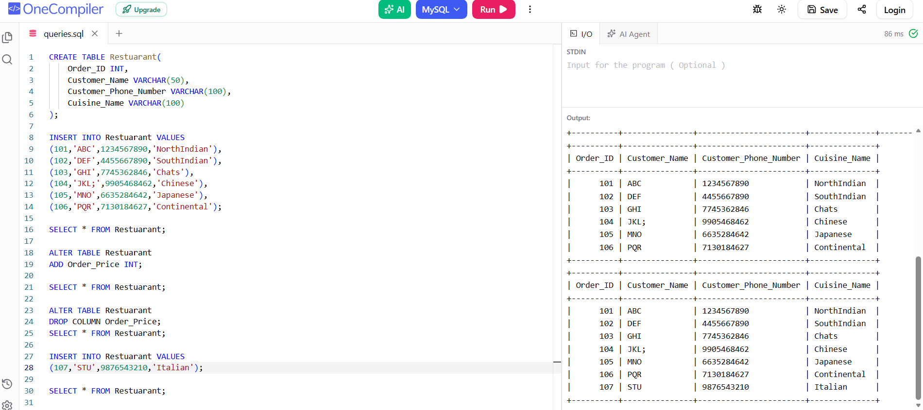

2) Update - Used to modify existing data in a table.
UPDATE Restuarant
SET Cuisine_Name = 'Italian'
WHERE Customer_Name = 'ABC';

SELECT * FROM Restuarant;

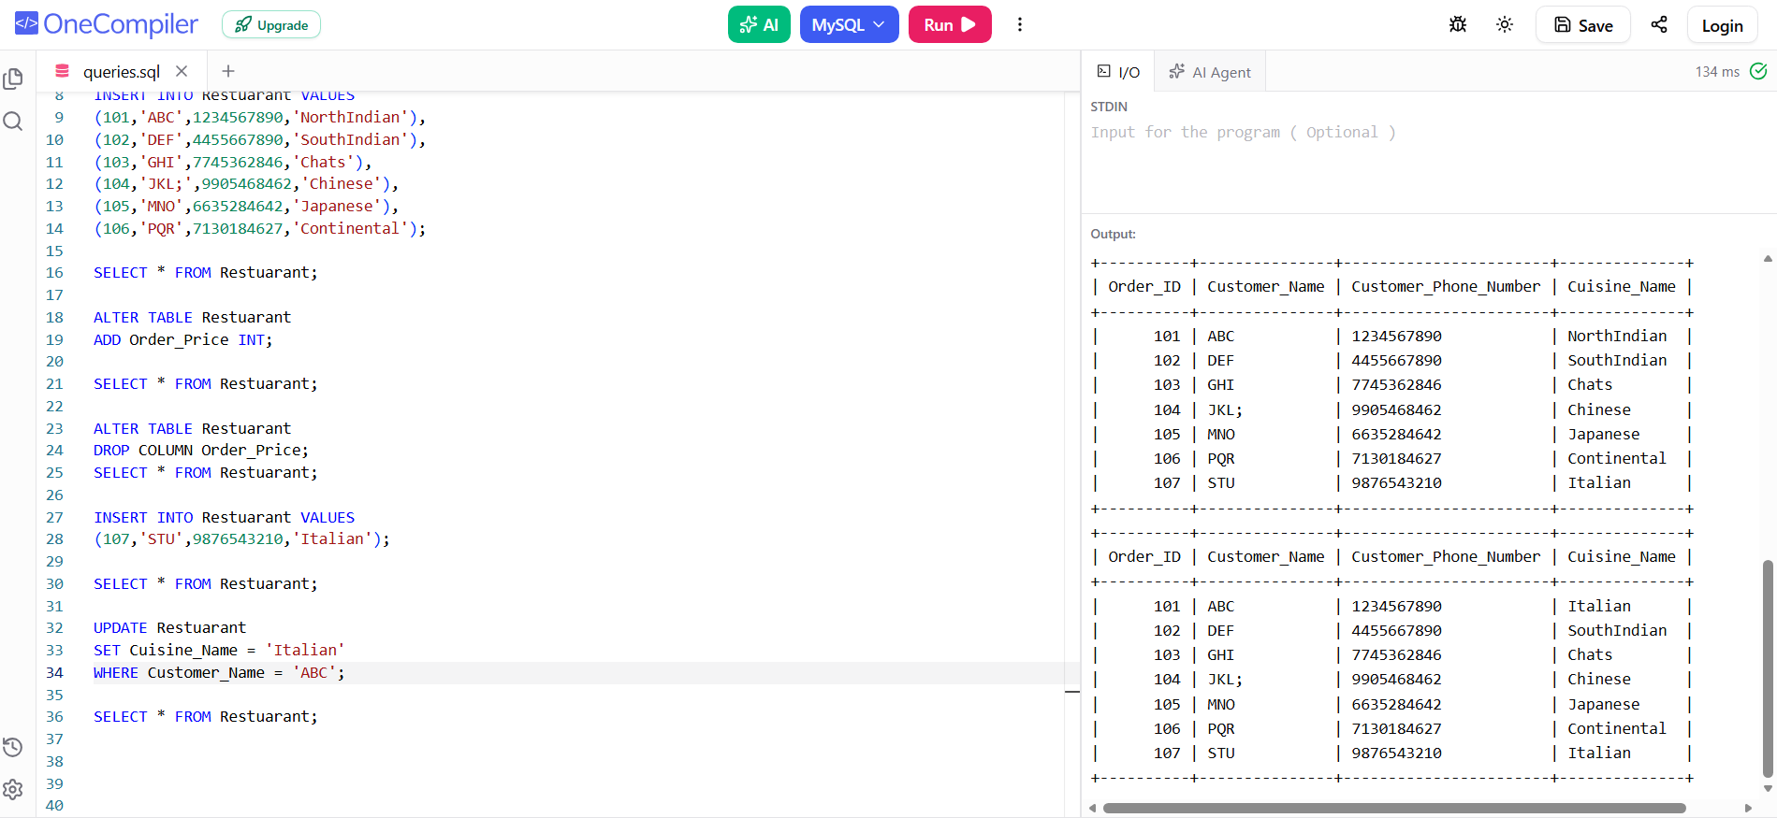

- Delete Command - The DELETE command is used to remove specific records (rows) from a table.

DELETE FROM Restuarant
WHERE Customer_Name = 'ABC';

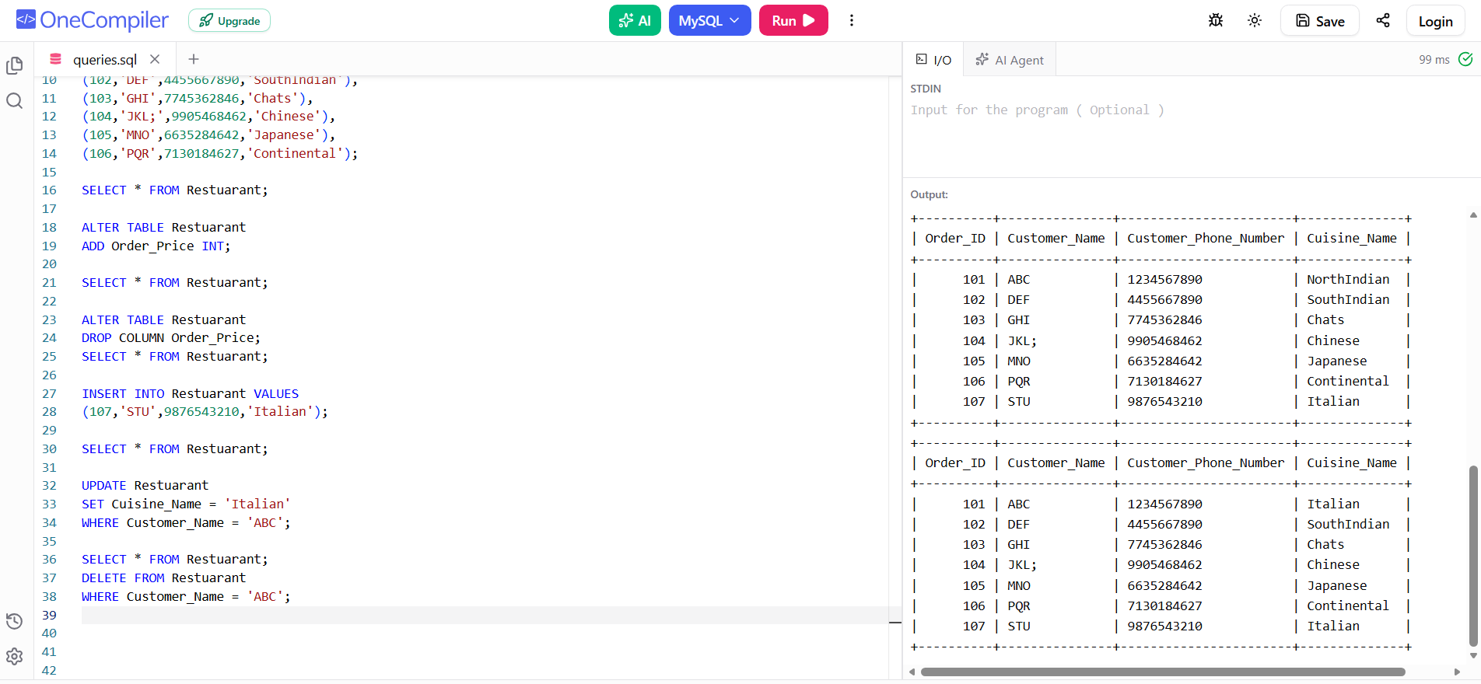

Github Link - https://github.com/mohith-1817/DBMS-ASSIGNMENTS.git

